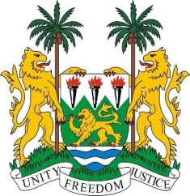
SIERRA LEONE
22nd Session of the UPR

MALDIVES

6 May 2015

Mr President,

Sierra Leone warmly welcomes the high-level delegation of the Maldives and thanks them for the informative update on their national report.

My delegation notes with appreciation the significant progress Maldives has made in promoting and protecting human rights, as evidenced by the de-facto moratorium on the death penalty which dates back six decades, the provision of universal healthcare, free education, and the enactment of the Anti-Torture Act of 2014.

While several concrete steps have been taken to implement the recommendations made during its last UPR in 2010, my delegation would like to urge the government to do more to protect the rights of migrants and human rights defenders.

Sierra Leone has the following recommendations:

- Consider abolishing the death penalty and eliminate mandatory death penalty sentences.
- Establish gender equality legislation to better protect the rights of women and girls.
- Strengthen and implement comprehensive climate change adaptation measures.

In view of the vulnerability of Maldives to the impacts of climate change, Sierra Leone calls on the international community to assist Maldives in putting in place robust adaptation measures.

To conclude, Sierra Leone wishes the Maldives every success in completing this second review cycle.

Thank you, Mr President.

